## Teleportation

(Unknown, n.d.)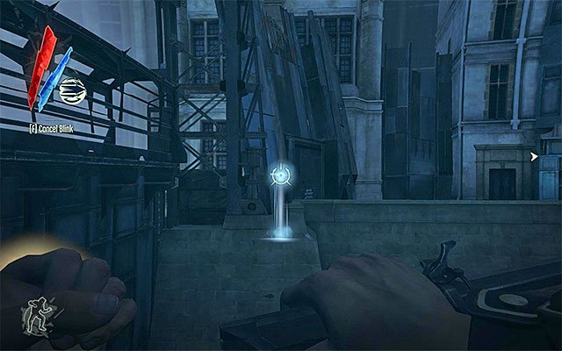

Creating a robust but mechanically unique teleportation technique for the player to use within the game.

Within my stealth game I want the player to have the ability to make short-Medium length teleportation. Originally I was thinking of creating something similar to dishonoured (above picture) however after reviewing my FYP with some friends and the mechanics I wanted one of them helped me come up with the idea of mixing FF15, and Dishonoured’s teleportation together.

The idea that has come from this hybrid fuse of mechanics is a knife the player would carry which they can then throw around the environment. Once thrown the player would then be able to teleport to wherever the knife landed however what I want to also do is allow the player the time to decide when they want to teleport to their knife. This would allow the teleport ability to be used in more interesting puzzles as well as making interactions with AI more open since you could distract the guard yourself in one direction and then teleport to the opposite direction that they turn to go with a pre planted knife.

## Knife Mechanics

Within engine there are a few things I’m going to want to have the knife able to do or planned to allow. These are:

* Ability to be thrown
* I’ll give the knife a basic projectile component from within Unreal and then tweak it as I develop the FYP till it has the distance and Arc I’m happy with.
* Aiming Arc showing where it’ll go before it is thrown
* This will be one of the most difficult things to do however as long as I keep the throwing values the same at all times I should be able to use the ‘PredictProjectilesByTraceChannel’ to get and show a throwing arc. The good thing about this is once I have this working I can then use it on my distraction items within the map being bottles and rocks
* Some form of effect or visual circle/radius allowing the player to have visual feedback to where it is on the floor.
* This will just require having a particle system in the shape of a circle appear. I’m not hugely confident with my speed or ability with particle systems so for now I’ll have a ring appear around the fallen location and if I have time look into giving it a particle effect.
* Possible timer for how long you have left before the knife reappears in your hand or your forced to Teleport to it. I’m thinking of having a 10-15 second timer before you’re forced to teleport to your knife since it’d mean that players have to think about when and where they throw their knife since they’re going to have to appear where it lands.
* This can be done through adding a timer by event or function event and having it tick down in the background until either it teleports the player or the player teleports themselves.
* Cooldown or recharge mechanic that limits the time before you can use it again
* Add a cooldown variable which is an integer or float that counts up and then resets the skill.
* The ability to pick up the knife if you walk over it
* This will be a simple HUD UI which will be toggled on when the knife’s ‘OnBeginOverlap’ Collision event detects the player within an area of the knife.

Then there are two features I won’t be able to implement right now since I either need other mechanics set in place or a more research into how I want them implemented properly

* Having the knife create a sound impact when it hits something
* For this mechanic all I’ll have to do is have a on an impact have it play a sound in the location, which can then be picked up by the AI. This will be implemented once I move onto the implementation of sound detection and AI.
* Have the ability to lock onto guards so you can do a Teleport takedown
* For this mechanic I already have an idea on how to implement it into engine. I’m thinking of having them player being able to press a button while aiming the knife which will then have a line trace come out of the players camera view which will then find out if the player is looking at an NPC. If they are, I’ll do a quick distance check to see if they’re within range and then if you are you’ll get a straight-line prediction path on to the aimed NPC and be able to take them out, if your not I can possibly put the same line trace in but have it appear Red to show you’re out of range.

# References

Unknown. (n.d.). *Crossing the river | Mission 5 - Lady Boyle's Last Party*. Retrieved October 2, 2020, from GamePressure: https://guides.gamepressure.com/dishonored/guide.asp?ID=16921