## Mantle/Climb

(Unkown, 2004)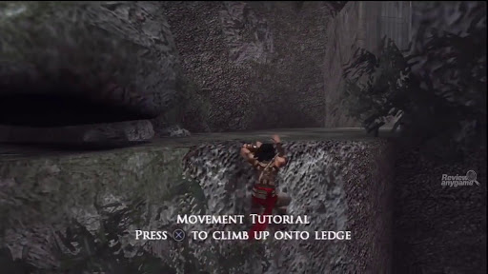

To better allow the player to move through the environment as well as showing the player that they should try and move to different areas within the map. I want to add a basic mantle/climbing ability to the player character.

What I want the player to be able to do:

* Grab ledges and climb up.
* Grab and Pull themselves up on to surfaces if the player were close and high enough to the ledge.

Once I have this in place, I will want to then add the ability for the player to be able to move left and right while ledge grabbed.

Many stealth games such as Hitman, Splinter cell and Dishonoured have the ability to do anywhere from basic to complex environmental traversal as to allow players to both control and move through the environment. This is a feeling I will be wanting to have within my own game.

## Mantle/Climb Mechanics

How to do this in the engine:

* Climbing through the use of Step Height
* Once way to allow for the player to climb over ledges and mantle objects is through using and changing the players Step Height. Step Height is a setting that has the engine check the height and how vertical the surface in front of the player is and then checks a set value to see if the player can go up it. Step height is typically used to easily allow for players to go up and down stairs without the need to have an inviable ramp the player can move up and down.
* Checking for ledges
* One method of checking for a ledge, as to allow for the player to grab onto ledges is through line traces another is collision boxes.
  + Line traces can be used for ledge grabbing though having a check where from the player characters head a line trace checks first if there’s an object in front of them and then secondly how close to the top of the object they are. This can be done through checking the vector coordinates between the character and the object found in the line trace.
  + Collision Boxes can be used for ledge grabbing to simplifying ledge grabbing and checks by having the player character just do a collision box check every time they jump. This method means that there will have to be custom selected zones for where the player can grab, which would be more annoying to implement into the entire map however you can use this method similar to that of the new tomb raider games through having a custom decal or object copied throughout the world to show the player where they can and can’t climb.
* Checking with jump
* A way of optimising this mechanic within the engine would be through having the check only ever happen when the player is jumping/in the air. This would limit the amount of time that resources would be used and should make sure the engine doesn’t get effected through doing the alternative which is having constant checks to see if the player can climb something.
* Moving left and right while ledge grabbed.
* The ability to move left and right when mantling would be a lot easier if I use the collision box method simply because it’d be easier to implement movement within the confines of a specified zone being the collision box. With this in mind I will probably create the climbing mechanic using the collision boxes to begin with however if I do have time go on to use line traces and checks to create a more open climbing mechanic that allows you to grab onto anywhere in the environment, although the ability to limit where the player can climb and go arguably helps with designing levels and areas.

# References

Unknown. (n.d.). *Crossing the river | Mission 5 - Lady Boyle's Last Party*. Retrieved October 2, 2020, from GamePressure: https://guides.gamepressure.com/dishonored/guide.asp?ID=16921

Unkown. (2004, November 30). *Prince of Persia: Warrior Within - PC*. Retrieved October 05, 2020, from Review Any Game: http://reviewanygame.com/prince-of-persia-warrior-within-pc.html